Emanate RadioVision™



Executive Summary

# Problem: Inefficiencies in Hospital Operations

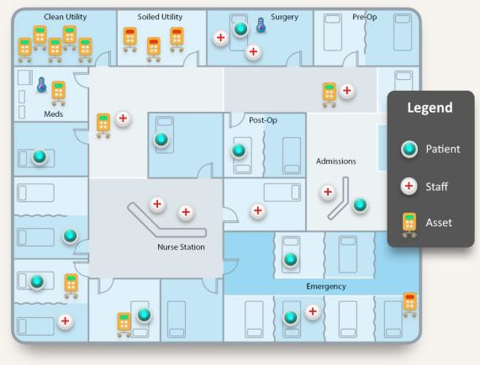Hospitals today face intense pressure to improve operational efficiency and patient care. A major challenge is the time and resources wasted tracking staff, patients, and vital equipment across complex facilities. Real-Time Location Systems (RTLS) have emerged as a solution – enabling automated tracking of assets and people to streamline workflows. However, legacy RTLS solutions are prohibitively expensive and proprietary, requiring roughly $1,500 in hardware per room plus ~$100 per tracking tag. These

systems often involve wired infrastructure (cabling, receivers) that drive up installation costs. As a result, adoption has been limited to large hospitals with big budgets, leaving an estimated 75–80% of hospitals without any RTLS in place. The high cost and complexity of current offerings have created a barrier, despite the clear benefits in reduced nurse time spent searching for equipment and improved patient throughput. There is a critical need for a low-cost, easy-deploy RTLS to unlock efficiency gains for the vast majority of hospitals.

# Solution: Emanate’s Disruptive RadioVision™ RTLS BLE Doorway Chokepoint

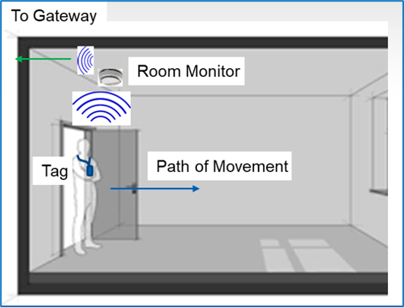Emanate Wireless’s RadioVision™ BLE Doorway Chokepoint is a next-generation RTLS solution that delivers clinical-grade, room-level accuracy (99.9%) at a fraction of the cost of legacy systems. The RadioVision™ platform uses Bluetooth Low Energy (BLE) 5.1 Angle of Arrival (AoA) technology combined with machine- learning algorithms to pinpoint locations. Small, battery-powered BLE “chokepoint” sensors are simply mounted in By looking at the path of travel of the tag, the device uses a trained ML algorithm to reliably determine

whether a tag has entered or exited the doorway – no new cables or wired infrastructure needed – drastically reducing installation cost and time. These BLE AoA sensors detect standard BLE signals (from inexpensive tags or even existing devices like smartphones, smartwatches, and medical equipment) and calculate the signal’s incoming angle. By looking at the path of travel of the tag, the device uses a trained ML algorithm to reliably determine whether a tag has entered or exited the doorway. This is a 10× improvement in accuracy over traditional Bluetooth beacon systems, ensuring virtually zero false room detections.

RadioVision™ works with off-the-shelf BLE tags and wearables – there’s no proprietary tag requirement. A nurse’s smartphone or a standard BLE badge can be tracked by the system, cutting the per-tag cost down to $10–$20 (or effectively $0 if using existing devices). The sensors themselves are low-cost and battery-powered, lasting years on a charge, so hospitals avoid expensive wired readers and can install the system in days instead of months.

On the software side, for OEM partners with their own application ecosystems, the RadioVision™ platform offers a seamless integration interface. It enables OEMs to incorporate real-time, room-level location data directly into their existing software environments—powering features like task orchestration, asset tracking, and workflow automation. This flexible approach allows partners to apply their own business logic, AI models, or custom rules on top of the data stream, delivering differentiated value and competitive advantage to their customers.

# Key Use Cases and Applications

* **Nurse Call Automation:** Auto-cancel patient alerts when staff enters the room, saving nurse time and documenting care.
* **Staff Duress & Safety:** Duress buttons on badges or watches trigger real-time location-based alerts.
* **PAR-Level & Asset Management:** Monitor and manage the distribution and availability of hospital-wide equipment.
* **Hand Hygiene Compliance:** Track compliance using dispenser and wearable data to reduce infection risks.
* **Patient–Staff Interaction Tracking:** Log interaction times to support quality of care and staffing visibility.
* **Equipment Utilization & Maintenance:** Monitor equipment use-patterns for optimized servicing and lifecycle management.

These use-cases show that RadioVision™ is not just a tracker but a platform for operational intelligence.

# Market Opportunity: Massive Untapped RTLS Adoption

The RTLS market in healthcare is already a >$1 billion/year opportunity in the U.S. and over

$2–3B globally. With only ~20–25% penetration, 75%+ of the market remains untapped due to cost and complexity. Analysts forecast ~18–20% CAGR growth, reaching $5–8B globally within the next 5–10 years.

Emanate addresses this opportunity with a 10× lower-cost model that enables adoption by mid-sized and community hospitals. As hospitals increasingly seek smart infrastructure for infection control, safety, and operational performance, Emanate can be the standard-bearer for affordable, scalable RTLS.

# Business Model: OEM Partnership Strategy

Emanate licenses RadioVision™ to RTLS providers and integrators as a finished hardware- software module.

* **OEM Delivery:** Partners integrate Emanate’s sensors and software into their own offerings.
* **Recurring Revenue:** Hardware sale + annual license and maintenance fees.
* **Analogy:** “We built the world’s best fuel system—we don’t want to sell the car.”

This model allows Emanate to scale fast, focus on technology innovation, and piggyback on existing healthcare sales channels.

# Traction: Early Validation

* **$1M order** secured from a leading healthcare provider OEM.
* **Deployed in pilot hospital**: Proven room-level accuracy, <1m error, sub-2s latency.
* **OEM Pipeline:** Multiple additional vendors in late-stage evaluation.
* **Awarded NSF SBIR Grant** for BLE-based RTLS innovation.

# IP & Competitive Moat

* Protected by **multiple patent families** covering BLE AoA triangulation and AI-driven orchestration.
* Team holds **140+ wireless, RTLS, and DSP patents**.
* Advanced machine learning models fine-tuned on real hospital data.
* Hardware, firmware, and algorithms form a vertically integrated and defensible solution.

# Leadership Team

* **Neil Diener (CEO):** BSEE MIT, MSEE USC. 36 patents. Former co-founder of Cognio (acquired by Cisco)
* **Gary Sugar (VP Eng):** BSEE/MSEE UMD. 59 patents. DSP and RF systems lead. Ex- Cognio.
* **Chandra Vaidyanathan, PhD:** EE, University of Minnesota. 32 patents. AI and DSP lead.
* **Yohannes Tesfai, PhD:** EE, University of Virginia. 16 patents. Sensor algorithm architect.

# Fundraising: $1M Angel Round Now Open

Emanate has a confirmed purchase order and a strong projected opportunity pipeline of additional customers. The company is currently raising $1 million in angel investment ahead of a planned institutional round, with the raise expected to close by mid-to-late July.

To reward early supporters, Emanate is offering a “Mr. Wonderful”-style royalty structure: angel investors in this round will receive approximately 5% of revenue from unit sales, paid out until they recoup 1x their investment (equivalent to royalties on the first ~100,000 units). This structure provides a compelling early return opportunity, with meaningful upside and customer traction already underway.

# Conclusion

Emanate is positioned to become the standard for affordable, room-accurate RTLS in healthcare. With a transformative product, early market validation, and a clear path to scale, the company is solving a problem that has eluded the industry for over a decade.

**Website** (in update): [www.emanatewireless.com](http://www.emanatewireless.com/)

**Product Brief & Pitch Deck**: Available upon request

*This document contains forward-looking statements regarding Emanate’s business, operations, and financial performance. These statements are based on current expectations and assumptions and are subject to risks and uncertainties that could cause actual results to differ materially. Past performance is not indicative of*

*future results. Investment involves risk, and prospective investors should conduct their own due diligence before making any investment decision.*